Enhanced thermal energy storage performance of salt hydrate phase change materials: effect of cellulose nanofibril and graphene nanoplatelet

Zhenghui Shen ª, Soojin Kwon ^{b}, Hak Lae Lee ^{a,c,d}, Martti Toivakka ^{e}, Kyudeok Oh ^{c,e,*}
ª Program in Environmental Materials Science, Department of Agriculture, Forestry and Bioresources, College of Agriculture and Life Sciences, Seoul National University, Seoul 08826, Korea
^{b} Department of Forest Biomaterials, North Carolina State University, Raleigh, North Carolina 27695, United States
^{c} Research Institute of Agriculture and Life Sciences, Seoul National University, Seoul 08826, Korea
^{d} State Key Laboratory of Biobased Material and Green Papermaking, Qilu University of Technology, Shandong Academy of Sciences, Jinan 250353, China
^{e} Laboratory of Natural Materials Technology, Åbo Akademi University, Turku 20500, Finland

Abstract: Thermal energy storage (TES) has attracted intense attention because of its positive contribution to sustainable energy utilization. To improve the TES performance of sodium acetate trihydrate (SAT), the combined use of cellulose nanofibril (CNF) and graphene nanoplatelet (GNP) was investigated to tackle the phase separation problem and to improve the thermal conductivity of SAT. Phase stability and rheology tests revealed that adding 0.8% of CNF to SAT increased viscosity, enhanced solid-like rheological behavior, and successfully eliminated phase separation. Meanwhile, the amphiphilicity of CNF facilitated the dispersion of GNP. Sodium phosphate dibasic dodecahydrate (DSP; Na₂HPO₄∙12H₂O) was selected as the nucleating agent, which reduced the supercooling degree of SAT to 2.1°C. Phase change materials (PCMs) were prepared by simply blending GNP pre-dispersed with CNF, DSP, and SAT. Due to the excellent thermal performance of GNP and its good dispersion by CNF, the prepared PCM composites showed enhanced thermal conductivity compared with that of pure SAT. Thermal reliability testing indicated that the melting point and enthalpy of the prepared PCM composites decreased after 100 melting/freezing cycles. Overall, PCM composites with enhanced performance were fabricated based on renewable, bio-based, and biodegradable nanocellulose. These composites can be used for certain TES applications.

Keywords: Thermal energy storage; Sodium acetate trihydrate; Cellulose nanofibril; Phase separation; Graphene nanoplatelet; Thermal conductivity

1. Introduction
Energy storage techniques have received intense attention due to ever-increasing concerns about the energy crisis and the sustainable development of human society. Thermal energy storage (TES) is one of the most studied topics among the energy storage techniques, which include hydrogen energy storage, pumped hydroelectric storage, superconducting magnetic energy storage, and supercapacitors [1]. Using efficient TES systems, mismatch between power production and demand can be minimized, and the security of energy supplies can be guaranteed [2]. Furthermore, TES systems possess higher overall efficiency, competitiveness in investment and running costs, and reduced environmental pollution, e.g., reduced CO₂ emissions [3]. Due to their large latent heat and high-energy storage density [4,5], phase change materials (PCMs) are widely used in TES applications. The stored thermal energy can be released and used at a later time for various applications, such as space heating, comfort applications in buildings, and power generation [6].
Sodium acetate trihydrate (SAT) is promising for TES applications, due mainly to its high volumetric energy storage density and desirable phase change temperatures [7]. SAT has appeared in many applications, e.g., household hot water supply systems, indoor heating systems [8], and solar heating systems [9]. Additionally, SAT is non-flammable, non-corrosive, non-toxic, and inexpensive compared with certain organic PCMs, for example, paraffin [2]. Nevertheless, due to its incongruent melting and high density, the anhydrous salt tends to settle to the container bottom during the phase transition process, and this so-called phase separation problem leads to gradually decreased energy storage capacity [10].
To eliminate the phase separation issue of SAT, various thickening agents, such as carboxymethyl cellulose, starch, xanthan gum, polyacrylic acid sodium salt, polyacrylamide, and poly(acrylamide-co-acrylic acid), were investigated in numerous studies [11−15]. These additives can increase the viscosity and decrease the fluidity of PCMs, consequently eliminating phase separation. In the current work, cellulose nanofibril (CNF) was used to avoid the phase separation of SAT. Because of its nanoscale dimensions, CNF not only maintains the intrinsic light weight, abundance, renewability, biodegradability, and recyclability of cellulose but also possesses other fascinating properties, such as a high aspect ratio and high specific surface area [16]. When dispersed in aqueous media, CNF readily forms networks even at a consistency as low as 0.15% [17]. Typically, a three-dimensional gel-like structure appears when the critical concentration of the nanofibril is reached [17,18]. The strength of this nanofibril network increases with increasing CNF content, as reflected by increased dynamic moduli [19,20]. These three-dimensional networks, formed via physical entanglements of the nanofibrils and with hydrogen bonding between the adjacent nanofibrils involved [21,22], would help hold the salt hydrate together and prevent it from sedimenting. Meanwhile, the addition of CNF would increase the overall viscosity, thereby hindering salt hydrate mobility and preventing phase separation. Previous work compared the effects of carboxymethyl cellulose, microfibrillated cellulose, unmodified CNF, and TEMPO-oxidized CNF on the phase stability of sodium sulfate decahydrate (Na₂SO₄10∙H₂O) and investigated the mechanism involved [23]. The authors concluded that the unmodified CNF provided the best stabilizing effect due to its high specific surface area and optimal electrostatic interactions between the cellulose fibrils and the dissolved salt hydrate due to its lower charge density, compared to chemically modified CNF. Given these good properties and its rigid web-like nanofibril networks, CNF was selected as the thickening agent of SAT.
In the cooling process of SAT, the lack of nucleating sites makes it crystallize at a temperature lower than its freezing point. This supercooling causes delayed heat release and an enlarged temperature difference between thermal energy storage and release [24]. Thus, for SAT to display a stable, efficient, and reliable melting/freezing process, its supercooling must be addressed. To suppress the supercooling of PCMs, nucleating agents (NAs) are typically used to trigger crystallization [13,14]. In the present study, screening and optimization of NAs were compared among four candidates to achieve the lowest supercooling degree.
Although SAT has a relatively high thermal conductivity compared with organic PCMs, it is always desirable to further improve its thermal conductivity, which speeds up heat transfer and thereby leads to a more efficient TES process [25]. Herein, graphene nanoplatelet (GNP) possessing superior heat-transfer performance was evaluated as a thermal conductivity enhancer. However, carbon nanomaterials typically suffer from agglomeration due to strong van der Waals forces among the nanoparticles [26]. As shown by a host of studies, CNF can effectively disperse carbon materials, such as expanded graphite, carbon nanotubes, and graphene [27−29], and does not hinder the intrinsic properties of dispersed carbon materials [30]. Hence, the secondary role of CNF here is to disperse GNP, providing accelerated heat transfer in PCMs.
In the present study, we tried to improve the thermal energy storage performance of SAT using CNF. The thickening effect of CNF for providing phase stability to SAT was investigated via phase stability and rheological tests, and optimization of the NA was performed to achieve the lowest supercooling degree. To improve heat-transfer performance, GNP was used as a thermal conductivity enhancer. The structure, thermal properties, and thermal reliability of the fabricated PCM composites were investigated systematically. Importantly, the prepared PCM composites may contribute to the development of a reliable and efficient TES system.

2. Materials and methods
2.1 Materials
Bleached eucalyptus kraft pulp was the starting material for the CNF. Anhydrous sodium acetate (SA; CH₃COONa), GNP (surface area 500 m²/g), sodium tetraborate decahydrate (borax; B₄Na₂O₇∙10H₂O), sodium phosphate tribasic dodecahydrate (Na₃PO₄∙12H₂O), sodium phosphate dibasic dodecahydrate (DSP; Na₂HPO₄∙12H₂O), and tetrasodium pyrophosphate decahydrate (Na₄P₂O₇∙10H₂O) were purchased from Sigma-Aldrich. All chemicals were used as received, and deionized water was used throughout all experiments.
2.2 Methods
Preparation of CNF
CNF was prepared by passing a 2 wt% pulp suspension through a grinder (Super Masscolloider; Masuko Sangyo Co., Ltd., Kawaguchi-city, Japan) more than 30 times. The gap between the two grinding plates was 80 μm, and the grinding speed was 1500 rpm. The zeta potential of the prepared CNF, examined using the Malvern Zetasizer (Nano-ZS; Malvern Instruments Ltd., Worcestershire, UK), was −34.8 ± 0.5 mV. The charge density determined by a titration method was 0.16 mmol/g CNF.
Preparation of CNF/GNP composites
GNP was homogenized in a CNF suspension, and different CNF/GNP dose ratios were adopted (0.8:0.5, 0.8:1.5, and 0.8:2.5), based on the dry weight of SAT. Specifically, certain amounts (0.625, 1.875, and 3.125 g) of GNP were added to a 0.5 wt% CNF suspension (200 g), followed by 60 min of homogenization using the Ultra-Turrax T50 homogenizer (Janke & Kunkel, IKA-Labortechnik, Staufen, Germany). There was a 2-min pause after each 10-min homogenization. Then the prepared CNF/GNP composites were collected by centrifugation (Combi R514; Hanil Scientific Inc., Gimpo, Korea) at 9000 rpm for 30 min. The obtained composites are denoted as CNF/GNP_{0.5}, CNF/GNP_{1.5}, and CNF/GNP_{2.5}, where the subscripts indicate the dose (%) of the GNP.
Preparation of PCM composites
Under magnetic stirring, CNF or CNF/GNP composites, DSP, and SA were sequentially dispersed in deionized water, and the SA:H₂O molar ratio was set to 1:3. The mixture was magnetically mixed for 1.5 h in a 70°C water bath to prepare the PCM composites. In all formulations, the doses of CNF (0.8%) and DSP (3%) were fixed, whereas the dose of GNP was varied (i.e., 0.5%, 1.5%, and 2.5%) when incorporating the prepared CNF/GNP composites.
Characterization
For the phase stability and fluidity tests, the “control” sample was prepared by simply dissolving the required amount of anhydrous sodium acetate (SA) in a specific amount of deionized water (the molar ratio of SA: H₂O is 1:3). Other samples were prepared by incorporation the needed amount of cellulose nanofibril (CNF) in the "control" sample while keeping the SA: H₂O molar ratio at 1:3, where the “H₂O” comes from all the ingredients. 18 g of the prepared samples were placed in glass tubes with lids, followed by incubating for 2 h in a 70°C water bath. Then these tubes were removed, and the phase stability was observed and recorded by digital images. The fluidity of the PCM composites was determined by inverting the bottles and noting the flowability of the samples.
Rheological properties were investigated at 65°C using a stress-controlled rotational rheometer (CVO-100-901; Malvern Instruments Ltd., Worcestershire, UK) with a cone–plate geometry (R = 40 mm, angle = 4°). To prevent crystallization, DSP was not added to the samples. Water droplets were uniformly distributed around the samples, and a cover was used to minimize moisture loss from the samples. The viscosity, storage (G') and loss (G'') moduli, and phase angle were determined to explore the flow behavior and viscoelasticity of PCMs with or without the addition of CNF or a CNF/GNP composite. On the log viscosity as a function of shear rate plot (5–1000 1/s shear rate region), the power law index n was calculated according to Equation (1) as follows [31]:
$τ=k{\dot{γ}}^{n-1}$ (1)
where $τ$ is the shear stress (Pa), $k$ reflects the individual fibril characteristics, and $\dot{γ}$ is the shear rate (1/s).
The experimental setup for the T-history method [32], which was used to determine the supercooling degrees of the PCM composites, is shown in Fig. 1. A PCM sample (10 g) was loaded into the glass test tube with a lid. Then, the test tube was incubated in a hot water bath at 70℃ for 1 h, followed by natural cooling in air. The real-time temperature was monitored by a PT100 thermocouple (Pico Technology Ltd., Cambridgeshire, UK), and was recorded using the PT-104 high-accuracy temperature data logger (Pico Technology Ltd., Cambridgeshire, UK). The supercooling degree was calculated according to Equation (2) as follows:
$∆T_{s}=T_{m}-T_{f}$ (2)
where $∆T_{s}$ is the supercooling degree (°C), $T_{m}$ is the melting point (°C), and $T_{f}$ denotes the freezing point (°C).

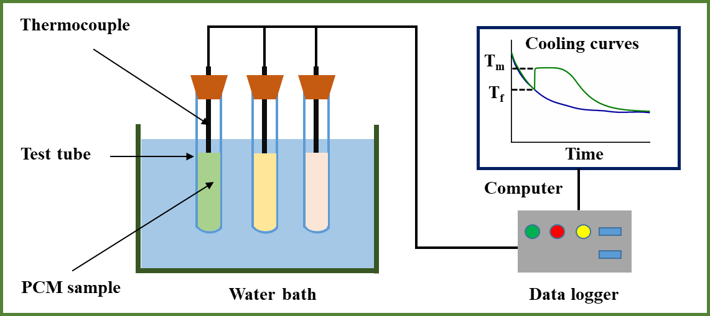
Fig. 1. Experimental setup of the cooling test.

The morphologies of the CNF, GNP, and CNF/GNP composites were examined by energy-filtering transmission electron microscopy (TEM; LIBRA 120; Carl Zeiss, Oberkochen, Germany). The structures of SAT and SAT-based PCM composites were observed using field-emission scanning electron microscopy (FE-SEM; Auriga; Carl Zeiss, Oberkochen, Germany) under a vacuum with an acceleration voltage of 2 kV. Fourier transform-infrared (FT-IR) spectra were recorded by the Nicolet 6700 spectrometer equipped with an attenuated total reflection (ATR) accessory (Thermo Scientific, Waltham, MA, USA). The crystalline phases of the samples were examined by X-ray diffraction (XRD; D8 Advance; Bruker, Germany) using Cu Kα1 radiation at λ = 1.5418 Å operating at 40 kV and 40 mA. The measurements were conducted at 2.4°/min.
The phase change properties of the samples in the melting process were determined by differential scanning calorimetry (DSC; Discovery DSC; TA Instruments Inc., New Castle, DE, USA). Samples were heated from 25°C to 70°C at a rate of 5°C/min. The weight loss of the samples was recorded by the Discovery thermogravimetric analyzer (TGA4000, PerkinElmer Inc., Waltham, MA, USA). Samples were heated from 30°C to 200°C at 5°C/min with a nitrogen flow rate of 20 mL/min. The thermal diffusivity of samples was measured by a laser flash apparatus (LFA467; Netzsch Instruments, Selb, Germany). Pellet specimens were prepared by pressing the powered samples in a stainless-steel mold at 100 kg/cm² for 10 min. The dimensions and weights of the prepared pellets were measured, followed by calculating their densities. The thermal conductivity was calculated according to Equation (3) as follows:
$k= α∙C_{P}∙ρ$ (3)
where $k$is the thermal conductivity (W/(m⋅K)), $α$ is the thermal diffusivity (mm²/s), $C_{P}$ is specific heat (J/(kg∙K)), and $ρ$ is the density of the pellet (kg/m³).
The thermal reliability of PCM composites was determined by examining their properties after 100 melting/freezing cycles. The melting points and enthalpies of the samples were measured by DSC, followed by comparison with those of PCM composites after only one melting/freezing cycle. The FT-IR spectra were also recorded and compared.

3. Results and discussion
3.1 Effectiveness of CNF in eliminating phase separation
Phase separation is a devastating issue for salt hydrate PCMs as it decreases the thermal energy storage capacity. In this work, CNF without any chemical modification was used to cope with the phase separation problem of SAT, considering its advantages in stabilizing the salt hydrate compared with chemically modified CNF [23]. Different amounts of CNF, i.e., 0.2%, 0.4%, 0.6%, 0.8%, and 1.0%, were added to SAT, and the phase stability of SAT/CNF mixtures in the melting/freezing process was investigated (Fig. 2a). When CNF was not added, the anhydrous salt settled to the bottom of containers with considerable liquid, mainly free water, above the salt crystals. As the level of CNF addition gradually increased from 0.2% to 0.6%, the lower part of these mixtures became more uniform, and a decreased height of free water at the surface was realized. The phase separation was eliminated when 0.8% and 1.0% CNF were used. CNF readily forms networks in the aqueous phase due to its high aspect ratio, and these entangled CNF networks contribute to the thickening effect that holds the anhydrous salt together and prevents its sedimentation [17,33]. Importantly, the strength of CNF networks increases with increasing CNF loading [34]. Phase stability tests indicated that CNF efficiently prevented the phase separation of SAT, and 0.8% CNF was sufficient to provide phase stability. The results of fluidity testing are shown in Fig. 2b. Without CNF or when an insufficient amount of CNF (0.2% or 0.4%) was added, the samples were highly fluid, and the mixtures easily flowed downward when the bottles were inverted. However, when the CNF dosage exceeded 0.6%, the mixtures had a gel-like appearance and did not flow downward. This indicates that the viscosity of SAT/CNF mixtures increased with increasing CNF content in the mixtures, which prevented sedimentation of the anhydrous salt and thus phase separation.
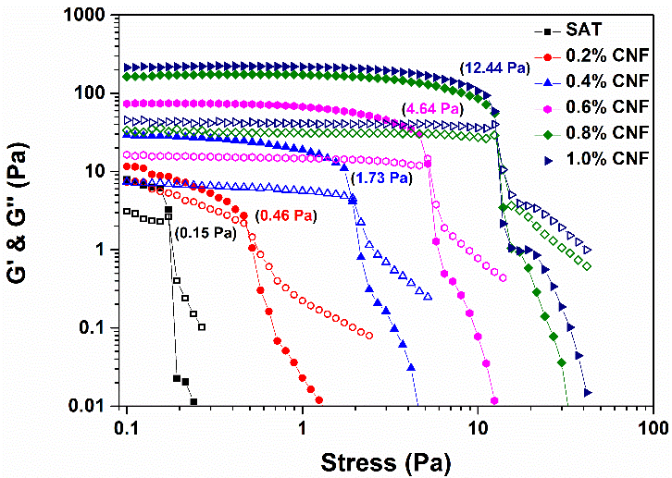
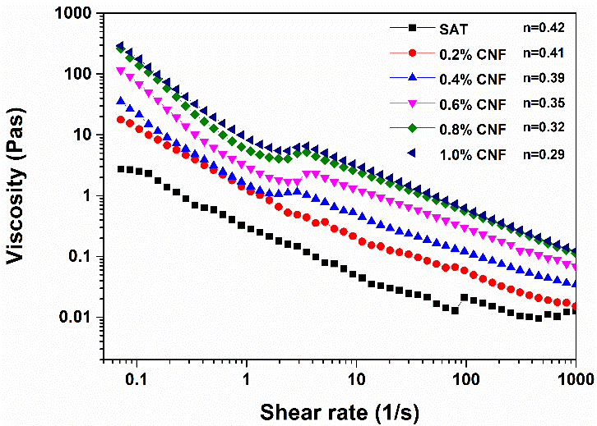
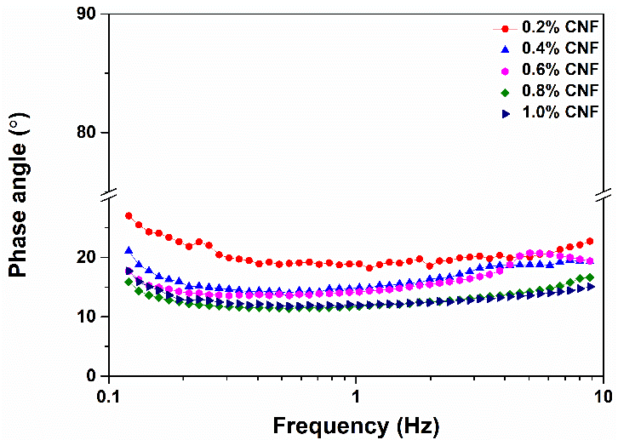
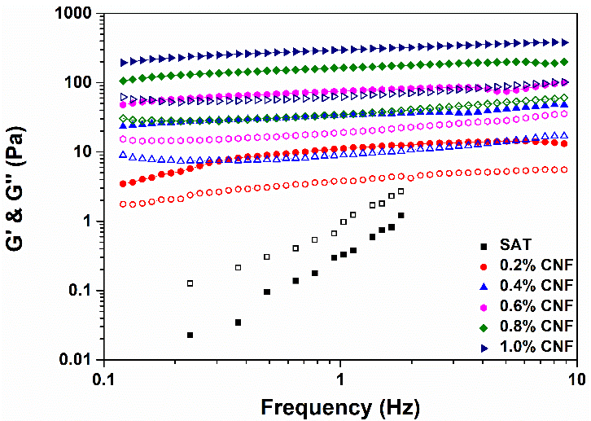
Control
0.2%
0.4%
0.6%
0.8%
1.0%
Control
0.2%
0.4%
0.6%
0.8%
1.0%
(a)
(b)
(c)
(d)
(e)
(f)
Fig. 2. Characterization of SAT/CNF mixtures: (a) Phase stability test, (b) Fluidity test, (c) Viscosity as a function of shear rate, (d) Amplitude sweep test, (e) Frequency sweep test and (f) Phase angle in the frequency sweep test. Closed symbols in (d) and (e): storage modulus (G'); open symbols in (d) and (e): loss modulus (G").

To confirm the above inferences, rheological tests were performed. Shear-thinning behavior appeared with increasing shear rate for all samples (Fig. 2c), as Iwamoto et al. similarly noted [35]. This is related to the pseudoplastic and thixotropic behaviors of CNF [36,37], as supported by the power law index of n < 1 (Fig. 2c). Unsurprisingly, with increased CNF content in SAT, the viscosity gradually increased, which was attributed to more interactions among the nanofibrils. A shoulder-like region appeared in the viscosity curves of CNF-containing samples, in which the viscosity stopped decreasing and then started to increase; this behavior was attributed to more entanglement of CNF in the suspensions [37]. However, when the shear rate increased continuously, these entangled networks broke down under the stronger shear force, leading to a further decrease in viscosity. Therefore, the observed rheological behaviors as a function of shear rate resulted from the formation and collapse of established CNF networks.
An amplitude sweep was performed to determine the viscoelasticity of the samples. For all samples containing CNF, the G' values were higher than the G'' values, indicating solid-like behavior of the SAT/CNF mixtures due to the entangled CNF [34]. With increasing CNF content, SAT/CNF mixtures presented higher G' due to more interactions among CNF. The yield stress, at which G' drops suddenly and samples start to flow, can be used to quantify the CNF network strength (Fig. 2d). The results indicate that the gel strength increased continuously when the CNF content approached 0.8%, after which only a small change was seen at a higher CNF content of 1.0%. This established that 0.8% CNF was sufficient to provide strong networks and prevent the phase separation, in agreement with the results of the phase stability test. A frequency sweep (Fig. 2e) revealed that G' was much higher than G'' over the entire adopted frequency range (0.1–10 Hz), again indicating the solid-like property of the samples. Pure SAT displayed a G'' that was higher than the G', which indicated liquid-like behavior. Fig. 2f shows that all of the samples had phase angles less than 45°, suggesting that the elastic portion dominated the viscous portion in the viscoelasticity of the samples, i.e., more solid-like behavior [38]. Based on these findings, it is clear that CNF enhanced the solid-like portion of the viscoelasticity of the samples due to nanofibril interactions, and 0.8% CNF was sufficient to avoid phase separation.

3.2 Screening of NAs and cooling tests
The screening of NAs was performed by measuring the supercooling degree via the T-history method. Four types of salt hydrate were used as NA to trigger the freezing stage of SAT in its cooling process. The cooling curves (Fig. 3) show that the supercooling degree of pure SAT was approximately 35°C, which must be suppressed for efficient thermal energy release. When only CNF was added to SAT, similar supercooling behavior was observed, indicating that the CNF could not decrease the supercooling degree. When 1% DSP was added, the crystallization of SAT did not occur until 44 min after starting the cooling process, and the supercooling degree was 33°C. With 2% DSP, the crystallization of SAT occurred at 22 min, and the supercooling degree was 27.4°C. Faster crystallization (< 5 min) of SAT occurred when more DSP was added, and the lowest supercooling degree, 2.1°C, was obtained when 3% DSP was added. As the DSP dosage was increased further to 4% and 5%, the supercooling degree increased to 4.1°C and 5.5°C, respectively. This was because the contact area between the nuclei and liquid/substrate increased when more NA was added, creating a resistance for nucleation [14]. Furthermore, the interactions among DSP nuclei may have hindered the growth of SAT crystals on the surfaces when more DSP was added.
Fig. 3. Screening of nucleating agents: effect of DSP.

The effect of the other three NAs (Na₄P₂O₇∙10H₂O, borax, and Na₃PO₄∙12H₂O) on supercooling suppression is presented in Fig. S1. Both the type and dosage of NA influenced the supercooling suppression. The obtained results reveal that DSP was the most effective NA at suppressing the supercooling of SAT, and the suitable dosage was 3%.
3.3 Incorporation of CNF/GNP to fabricate PCM composites
Because of their fascinating thermal properties, carbon-based materials are extensively used to enhance the heat-transfer performance of PCMs [39]. Graphite and its derivatives, including graphene (a single sheet of graphite), graphene oxide (GO), and reduced GO (rGO), can be used as thermal-conductivity enhancers. Although GO and rGO have better self-dispersing ability than that of graphite or graphene, irreversible structural defects result from the harsh preparation conditions, i.e., strongly oxidizing for GO preparation and reducing for rGO preparation. These defects consequently deteriorate the originally excellent thermal properties of graphite [40]. Additionally, chemical modification to improve the dispersion of graphite or graphene is complex, costly, and environmentally unfriendly. We tested GNP as the thermal conductivity enhancer and used a green dispersing process with CNF to avoid thermal performance deterioration. To this end, CNF/GNP composites were prepared by a mechanical homogenization process. In this case, the CNF acted as a dispersing agent due to its amphiphilicity. Specifically, CNF can attach to GNP via hydrophobic interactions [29]. The morphologies of the CNF, GNP, and CNF/GNP composites are shown in Fig. 4. The CNF exhibited the typical morphology of a high aspect ratio and entangled network structure. Commercial GNP has a multilayered structure, i.e., several layers of graphene are stacked together due to the ease of aggregation of the nanomaterials. When the dosage of GNP was 0.5%, a single-layered GNP structure was evident in TEM images, which indicated good exfoliation and dispersion of the GNP by the CNF. When the dosage of GNP increased to 2.5%, the dispersion was not effective, and some GNP aggregation was visible. This suggested that a suitable ratio between CNF and GNP is critical for improving the dispersion of GNP. We then blended the CNF/GNP composites with SAT and DSP to fabricate SAT-based PCM composites (Fig. 5).
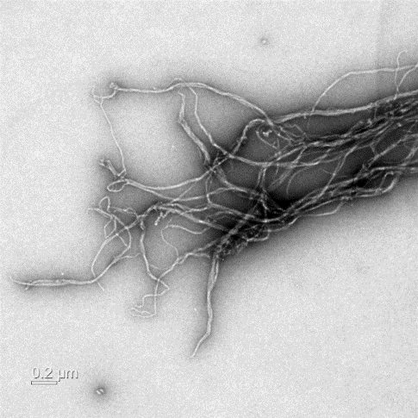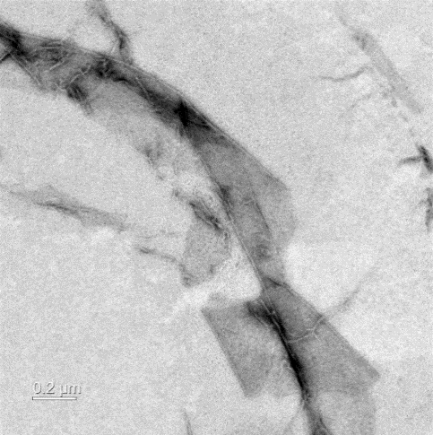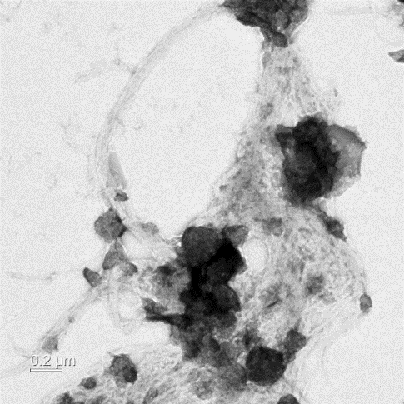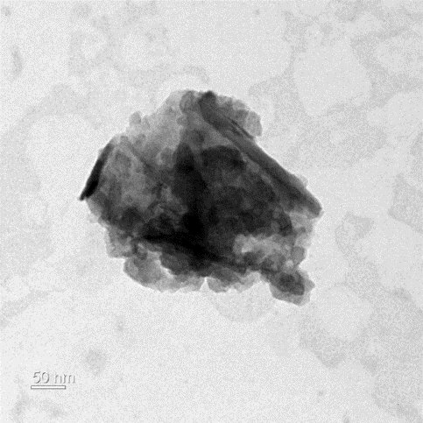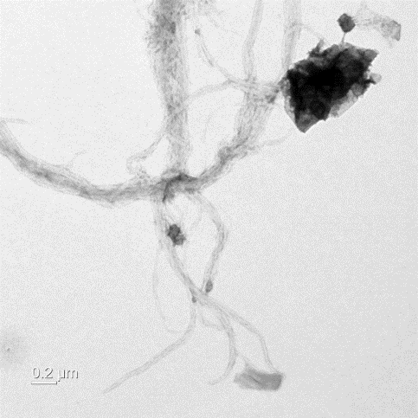
GNP
CNF
GNP
CNF
(a)
(b)
(c)
(e)
GNP
CNF
(d)
Fig. 4. TEM images of (a) CNF, (b) GNP, (c) CNF/GNP_{0.5}, (d) CNF/GNP_{1.5}, and (e) CNF/GNP_{2.5}.

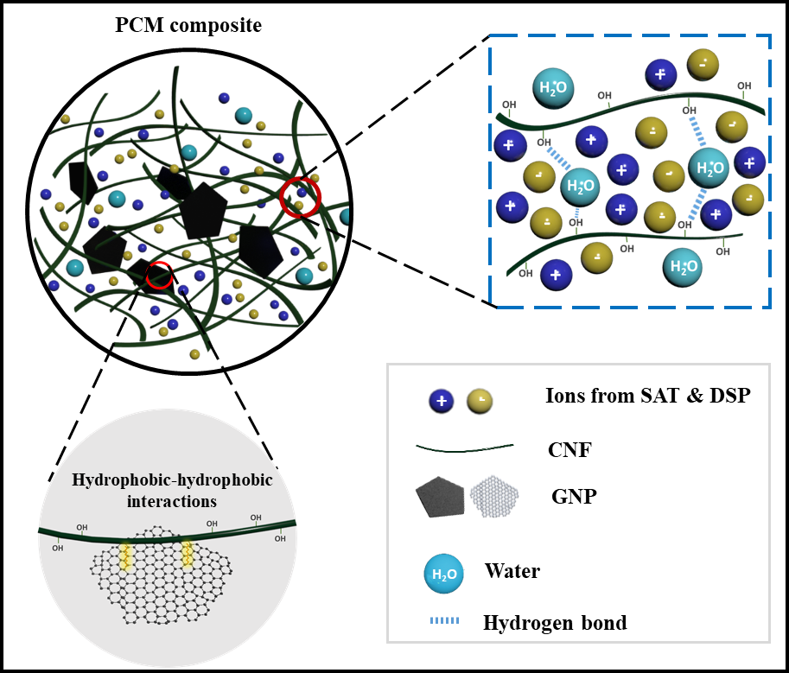
Fig. 5. Schematic illustration of the preparation of PCM composites.

The dispersing state of GNP in SAT is shown in Fig. S2. A stable phase was achieved when 0.8% CNF was added, however, both GNP and salt hydrate settled down without the addition of CNF. This again suggests the effectiveness of CNF in providing phase stability to the final PCM composites. The rheological properties, including viscosity, viscoelasticity, and phase angle of GNP-containing PCM samples, were analyzed (Fig. S3). These results indicated that the composites were phase-stable, with increased viscosity and solid-like performance. The effect of GNP addition on the supercooling suppression of SAT was also determined (Fig. S4). The results show that SAT crystallized rapidly within 5 min after cooling was initiated, and the supercooling degrees of these PCM composites were mostly unchanged with the addition of GNP. These findings suggest that the addition of GNP does not harm the nucleating effect of DSP. Fashandi and Leung reported that the addition of GNP was detrimental at all doses to the suppression of supercooling of SAT [41]. Those authors attributed this to the agglomeration of GNP, which created porous spaces in the PCM matrix and restricted the mobility of SAT molecules, consequently impeding the crystallization of SAT. In our work, the relatively constant supercooling degree upon the addition of GNP indicates that the dispersion of GNP was uniform and did not affect the crystallization of SAT.
The structures of the prepared PCM composites were examined via FE-SEM. Low-magnification FE-SEM images indicated good compatibility among the components (Fig. 6). Fig. 6a shows that large voids were present in the crystal structure of pure SAT, and that the crystal size was as large as tens of microns. With the addition of other components, i.e., CNF, DSP, and GNP, the crystal size of SAT decreased, and the PCM composites became more compact. High-magnification FE-SEM images (Fig. 7) were obtained to visualize the internal structure of the PCM composites, as well as the connections and interactions among the components. The entangled CNF network, hydrogen bonding between CNF and SAT, and hydrophobic interactions between CNF and GNP contributed to these interactions (Fig. 5). The CNF appeared to act as bridges to connect other components, as can be seen in all four images. While it is difficult to identify the nanoplatelets in the SAT-based PCM composite at the GNP dose of 0.5% (Fig. 7b), they are more clearly visible at higher doses (Fig. 7c, d). In short, PCM composites with compact structures were successfully prepared, and these compact structures likely contributed to improved heat transfer.
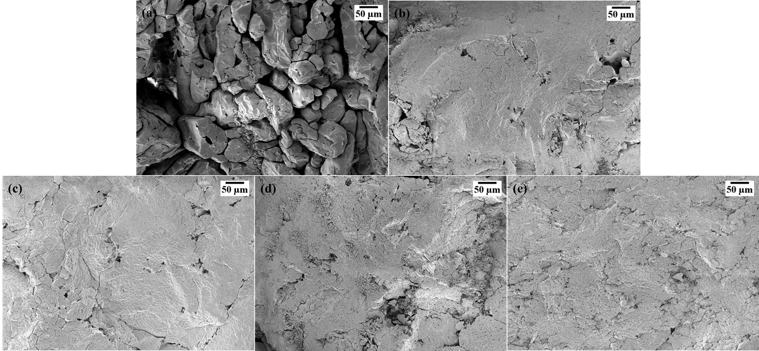
Fig. 6. Low-magnification FE-SEM images of SAT (a) and SAT-based PCM composites: (b) 0%, (c) 0.5%, (d) 1.5%, and (e) 2.5% GNP. Magnification: 400×.

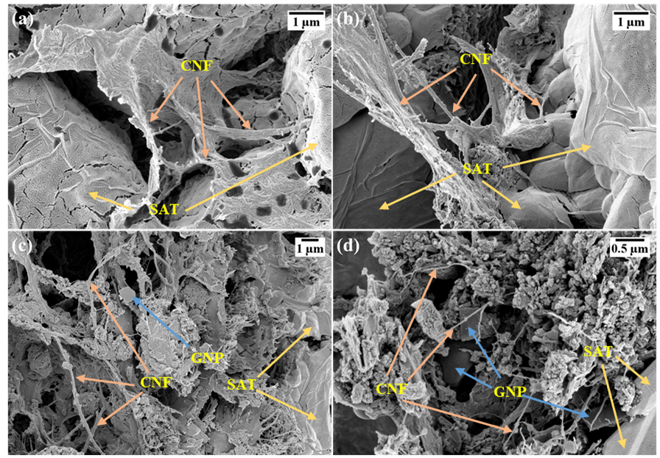
Fig. 7. High-magnification FE-SEM images of SAT-based PCM composites: (a) 0%, (b) 0.5%, (c) 1.5%, and (d) 2.5% GNP. Magnification: (a) and (b) 30,000×, (c) 15,000×, and (d) 50,000×.

3.4 Characterization of the chemical structure and crystalline phases
The chemical structure and components of the SAT-based PCM composites were investigated by attenuated total reflection FT-IR (Fig. 8 and S5). In the spectrum of SAT, the broad peak between 3000 and 3700 cm⁻¹ belongs to the stretching band of O–H, contributed by the water of crystallization. The peak at 1700 cm⁻¹ is assigned to the C=O stretching, which is a characteristic peak of a carboxyl salt [42]. Peaks ascribed to hydroxyl groups (3328 cm⁻¹), and characteristic glucosidic linkages of cellulose (897 cm⁻¹) [43], can be found in the spectrum of CNF. The spectrum of DSP shows the peaks for the water of crystallization (3241 cm⁻¹), characteristic P–O stretching (1066 cm⁻¹), and PO–H bending (984 cm⁻¹) [44]. In the spectrum of GNP, the two peaks at 3442 and 1637 cm⁻¹ are assigned to O–H stretching and C=C bending vibrations, respectively [45]. Thus, all of the characteristic peaks of each component, i.e., SAT, CNF, DSP, and GNP, were present in the spectrum of the PCM composites, and there were no new peaks generated.
Fig. 8. FT-IR spectra of SAT-based PCM composites and their components.

The XRD patterns of the SAT-based PCM composites and the components are shown in Fig. 9 and S6. In the diffraction pattern of SAT, the peaks at 19.0°, 22.4°, and 29.7° correspond to the (011), (200), and (211) planes, respectively [46]. The CNF showed two broad peaks centered at 16.3° and 22.6°, corresponding to the (110) and (200) crystal planes, which are typically attributed to the cellulose type I structure [47]. The diffraction pattern of GNP showed a peak at 26.4°, corresponding to the (002) plane [45]. Analogous to the analysis of the FT-IR spectra, the diffraction peaks of the PCM composites corresponded to a mixture of the peaks from each component, and no new peaks were present.
Fig. 9. XRD patterns of SAT-based PCM composites and their components.

3.5 Characterization of the thermal properties
The DSC curves of SAT and its composites are presented in Fig. 10. Pure SAT had an enthalpy of 270.2 kJ/kg and melting point of 58.7°C, which are quite close to the reported theoretical values of 264 kJ/kg and 58°C. The minor differences may stem from the small sample size (< 50 mg) used for the DSC measurements. The melting points and enthalpies of SAT and its composites determined by DSC are summarized in Table 1. It is clear that the melting points were all approximately 58°C, and the enthalpies of the composites decreased slightly with increasing GNP content. Since no chemical reactions occurred based on the FT-IR and XRD analyses, the slightly lower enthalpies might have been caused by the decreased SAT percentage in the composites when other substances were incorporated.
Fig. 10. DSC curves of SAT and SAT-based PCM composites.

Table 1. Melting points and enthalpies of SAT and SAT-based PCM composites.
PCM | Melting point (°C) | Enthalpy (kJ/kg)
SAT | 58.7 | 270.2
0% GNP | 58.5 | 268.7
0.5% GNP | 58.5 | 263.9
1.5% GNP | 58.3 | 257.4
2.5% GNP | 58.2 | 255.1

The thermogravimetric analyzer curves of SAT and its composites are presented in Fig. 11. The free water in these samples evaporated first as the temperature increased above 35°C. When the temperature reached the melting points of the samples, the bonds between anhydrous salt and water of crystallization started to break. When the temperature continued to increase, the unbonded water of crystallization evaporated. When the temperature reached 138°C, almost all of the water of crystallization in SAT was lost, and the weight fraction of anhydrous SAT (60.03%) was quite close to the theoretical solid content of pure SAT (60.28%). For SAT-based PCM composites, most of the water of crystallization evaporated at a higher temperature (~145°C for GNP-containing composites and 150°C for composites without GNP), indicating a stronger water-holding ability and better thermal stability of these samples. Hydrogen bonding between CNF and the water of crystallization in SAT may have contributed to this phenomenon. The final solid fraction of PCM composites was higher than that of SAT, which is because more solid substances added to SAT led to an increased solid content of the PCM composites. Thermogravimetry suggested that the prepared PCM composite can hold water more strongly during the melting process of SAT, which is favorable for applications at elevated temperatures.
Fig. 11. Thermogravimetry curves of SAT and SAT-based PCM composites.

The heat-transfer performance of a PCM determines the efficiency of the thermal energy storage and release process. The thermal conductivity of the prepared PCM composites was determined according to Equation (3). The method was investigated by Kleiner et al. [48], who concluded that this method is suitable for determining the thermal conductivity of a salt hydrate. The measured density, specific heat, and thermal diffusivity are tabulated in Tables S1 and S2. The calculated thermal conductivity is presented in Fig. 12. The thermal conductivity of pure SAT was 0.442 W/(m⋅K), quite similar to the value (0.433 W/(m⋅K)) reported by Johansen et al [49]. The thermal conductivity of PCMs containing GNP increased with increasing GNP dosage. This improvement was attributed to the excellent heat-transfer performance of the two-dimensional carbon nanomaterial, which acted as the thermal conductive channel in the PCM composites. When the dosage of GNP was 2.5%, the thermal conductivity reached the maximum value, i.e., 0.686 W/(m⋅K), which is 55.2% higher than that of pure SAT. Although the obtained results indicate that the prepared PCM composite exhibited improved heat-transfer performance, the low addition level of GNP (2.5%) might be insufficient to give a very high thermal conductivity. Our thermal conductivity results agree well with the reported values in the work by Yang et al [50]. The thermal conductivity of the prepared PCM composite is around 0.55 W/(m⋅K) when 2.5% GNP was used in their work, and the thermal conductivity was 1.35 W/(m⋅K) with 5.3% GNP added. The concern of adding much GNP in our work is that doing so not only increases the cost of final products but also causes more aggregation of these carbon nanomaterials. Moreover, both the type and dose of carbon nanomaterials affect their efficiency in improving the thermal conductivity of prepared composites [51], which should be concerned in research.
Fig. 12. Thermal conductivity of SAT and SAT-based PCM composites.

The thermal reliability of PCMs is important, as it determines the service life of a thermal energy storage system. Thermal reliability testing using FT-IR (Fig. 13a and S7) showed that the original characteristic peaks did not disappear or shift before and after the thermal cycles, and no new peaks emerged. Besides, the cyclic melting/freezing process did not change the intensities of all the peaks much. This indicated that the prepared PCM composites were chemically stable during the phase transition process, and no chemical reaction occurred after the numerous thermal cycles, demonstrating good thermal reliability of the prepared PCM composites. The melting point of the prepared PCM composite (2.5% GNP condition; Fig. 13b) after 100 melting/freezing cycles was 57.9°C, almost the same as the theoretical melting point of SAT (58°C). The enthalpy of this sample after 100 cycles was 229.3 kJ/kg, which is 10% lower than the enthalpy after one melting/freezing cycle. Fig. S8 shows the DSC curves of the prepared PCM composites with different GNP contents after 100 melting/freezing cycles; their melting points and enthalpies are summarized in Table S3. The melting points were quite close to 58°C, and the reduction in their enthalpies was in the range of 8–12%. Although the obtained thermal reliability result of current work
is comparable with the results of some studies [8,52,53], more effort on improving the long-term thermal reliability of PCM composites and more cycles of melting/freezing should be performed in our future work.
(a)
(b)
Fig. 13. Thermal reliability tests: (a) FT-IR spectra of PCM composites before and after 100 melting/freezing cycles and (b) DSC curves of PCM composites before and after 100 melting/freezing cycles.

4. Conclusions
Salt hydrate PCM composites with stable phase, minimal supercooling, and improved thermal properties were prepared. As a green and versatile nanomaterial, CNF efficiently addressed the phase separation problem by increasing the viscosity and elastic modulus of SAT, which resulted mainly from entangled networks of CNF. With the addition of 3% DSP as a NA, the supercooling degree of SAT was suppressed to only 2.1°C. Compared with pure SAT, the prepared PCM composites had more compact structures and smaller crystal sizes. When GNP pre-dispersed in CNF was used, the thermal properties of the prepared PCM composites were enhanced, as reflected by TGA and thermal conductivity analyses. After 100 melting/freezing cycles, their enthalpies decreased around 10%, which should be improved for long-term end-uses. In summary, the prepared salt hydrate PCM composites showed improved thermal energy storage performances, making them more suitable for practical applications. Additionally, this research provides clues for the application of green natural polymers, e.g., CNF, to an emerging research field, i.e., thermal energy storage.

■ Associated Content
Supplemental Material includes:
Screening of nucleating agents, digital image, rheological tests, cooling curves, FT-IR spectra, XRD patterns, DSC curves, dimension, density, specific heat and thermal diffusivity of PCM pellets.

Corresponding Author
*E-mail: ogd0310@snu.ac.kr (Kyudeok Oh).

Declaration of Competing Interest
The authors declare that they have no known competing financial interests or personal relationships that could have appeared to influence the work reported in this paper.

Acknowledgements
This work was financially supported by a National Research Foundation of Korea (NRF) Grant funded by the Korean government (NRF-2019R1C1C1003126). The author Zhenghui Shen acknowledges the support from the China Scholarship Council (CSC, grant No. 201708120051). Professor Hye Jung Youn is thanked for her assistance in preparing CNF.

References
[1] D. Akinyele, R. Rayudu, Review of energy storage technologies for sustainable power networks, Sustain. Energy Technol. Assess. 8 (2014) 74-91. https://doi.org/10.1016/j.seta.2014.07.004.
[2] B. Zalba, J.M. Marın, L.F. Cabeza, H. Mehling, Review on thermal energy storage with phase change: materials, heat transfer analysis and applications, Appl. Therm. Eng. 23 (2003) 251−283.
https://doi.org/10.1016/s1359-4311(02)00192-8.
[3] I. Dincer, M. Rosen, Thermal energy storage: systems and applications, 2nd ed., John Wiley & Sons, Chichester, 2010.
[4] X. Huang, G. Alva, Y. Jia, G. Fang, Morphological characterization and applications of phase change materials in thermal energy storage: A review, Renew. Sust. Energ. Rev. 72 (2017) 128−145.
https://doi.org/10.1016/j.rser.2017.01.048.
[5] A. Sharma, V.V. Tyagi, C.R. Chen, D. Buddhi, Review on thermal energy storage with phase change materials and applications, Renew. Sust. Energ. Rev. 13 (2009) 318−345. https://doi.org/10.1016/j.rser.2007.10.005.
[6] I. Sarbu, C.J.S. Sebarchievici, A comprehensive review of thermal energy storage, Sustainability 10 (2018) 191. https://doi.org/10.3390/su10010191.
[7] N. Kumar, J. Hirschey, T.J. LaClair, K.R. Gluesenkamp, S. Graham, Review of stability and thermal conductivity enhancements for salt hydrates, J. Energy Storage 24 (2019) 100794. https://doi.org/10.1016/j.est.2019.100794.
[8] W. Fu, T. Zou, X. Liang, S. Wang, X. Gao, Z. Zhang, Y. Fang, Thermal properties and thermal conductivity enhancement of composite phase change material using sodium acetate trihydrate-urea/expanded graphite for radiant floor heating system, Appl. Therm. Eng. 138 (2018) 618−626. https://doi.org/10.1016/j.applthermaleng.2018.04.102.
[9] G. Englmair, C. Moser, S. Furbo, M. Dannemand, J. Fan, Design and functionality of a segmented heat-storage prototype utilizing stable supercooling of sodium acetate trihydrate in a solar heating system, Appl. Energy 221 (2018) 522−534. https://doi.org/10.1016/j.apenergy.2018.03.124.
[10] M.M. Farid, A.M. Khudhair, S.A.K. Razack, S. Al-Hallaj, A review on phase change energy storage: materials and applications, Energy Convers. Manag. 45 (2004) 1597−1615. https://doi.org/10.1016/j.enconman.2003.09.015.
[11] L.F. Cabeza, G. Svensson, S. Hiebler, H. Mehling, Thermal performance of sodium acetate trihydrate thickened with different materials as phase change energy storage material, Appl. Therm. Eng. 23 (2003) 1697−1704. https://doi.org/10.1016/s1359-4311(03)00107-8.
[12] W. Kong, M. Dannemand, J. Brinkø Berg, J. Fan, G. Englmair, J. Dragsted, S. Furbo, Experimental investigations on phase separation for different heights of sodium acetate water mixtures under different conditions, Appl. Therm. Eng. 148 (2019) 796−805. https://doi.org/10.1016/j.applthermaleng.2018.10.017.
[13] J. Liu, C. Zhu, W. Liang, Y. Li, H. Bai, Q. Guo, C. Wang, Experimental investigation on micro-scale phase change material based on sodium acetate trihydrate for thermal storage, Sol. Energy 193 (2019) 413−421. https://doi.org/10.1016/j.solener.2019.09.050.
[14] Y. Wang, K. Yu, H. Peng, X. Ling, Preparation and thermal properties of sodium acetate trihydrate as a novel phase change material for energy storage, Energy 167 (2019) 269−274. https://doi.org/10.1016/j.energy.2018.10.164.
[15] W. Hua, X. Zhang, M.J. Muthoka, X. Han, Preparation and performance analysis of modified sodium acetate trihydrate, Materials 11 (2018) 1016. https://doi.org/10.3390/ma11061016.
[16] H.A. Khalil, Y. Davoudpour, M.N. Islam, A. Mustapha, K. Sudesh, R. Dungani, M. Jawaid, Production and modification of nanofibrillated cellulose using various mechanical processes: a review, Carbohydr. Polym. 99 (2014) 649−665. https://doi.org/10.1016/j.carbpol.2013.08.069.
[17] M. Pääkkö, M. Ankerfors, H. Kosonen, A. Nykänen, S. Ahola, M. Österberg, J. Ruokolainen, J. Laine, P.T. Larsson, O. Ikkala, Enzymatic hydrolysis combined with mechanical shearing and high-pressure homogenization for nanoscale cellulose fibrils and strong gels, Biomacromolecules 8 (2007) 1934−1941. https://doi.org/10.1021/bm061215p.
[18] C. Salas, T. Nypelö, C. Rodriguez-Abreu, C. Carrillo, O.J. Rojas, Nanocellulose properties and applications in colloids and interfaces, Curr. Opin. Colloid. Interface Sci. 19 (2014) 383−396. https://doi.org/10.1016/j.cocis.2014.10.003.
[19] K. Dimic-Misic, A. Puisto, P. Gane, K. Nieminen, M. Alava, J. Paltakari, T. Maloney, The role of MFC/NFC swelling in the rheological behavior and dewatering of high consistency furnishes, Cellulose 20 (2013) 2847−2861. https://doi.org/10.1007/s10570-013-0076-3.
[20] O. Nechyporchuk, M.N. Belgacem, F. Pignon, Rheological properties of micro-/nanofibrillated cellulose suspensions: wall-slip and shear banding phenomena, Carbohydr. Polym. 112 (2014) 432−439. https://doi.org/10.1016/j.carbpol.2014.05.092.
[21] X. Xu, F. Liu, L. Jiang, J. Zhu, D. Haagenson, D.P. Wiesenborn, Cellulose nanocrystals vs. cellulose nanofibrils: a comparative study on their microstructures and effects as polymer reinforcing agents, ACS Appl. Mater. Interfaces 5 (2013) 2999-3009. https://doi.org/10.1021/am302624t.
[22] H.-M. Ng, L.T. Sin, T.-T. Tee, S.-T. Bee, D. Hui, C.-Y. Low, A. Rahmat, Extraction of cellulose nanocrystals from plant sources for application as reinforcing agent in polymers, Compos. B. Eng. 75 (2015) 176-200. https://doi.org/10.1016/j.compositesb.2015.01.008.
[23] K. Oh, S. Kwon, W. Xu, X. Wang, M. Toivakka, Effect of micro-and nanofibrillated cellulose on the phase stability of sodium sulfate decahydrate based phase change material, Cellulose 27 (2020) 5003-5016. https://doi.org/10.1007/s10570-020-03121-w.
[24] A. Safari, R. Saidur, F.A. Sulaiman, Y. Xu, J. Dong, A review on supercooling of phase change materials in thermal energy storage systems, Renew. Sust. Energ. Rev. 70 (2017) 905−919. https://doi.org/10.1016/j.rser.2016.11.272.
[25] H. Lei, C. Fu, Y. Zou, S. Guo, J. Huo, A thermal energy storage composite with sensing function and its thermal conductivity and thermal effusivity enhancement, J. Mater. Chem. A 7 (2019) 6720−6729. https://doi.org/10.1039/c8ta11753e.
[26] W. Yang, Z. Zhao, K. Wu, R. Huang, T. Liu, H. Jiang, F. Chen, Q. Fu, Ultrathin flexible reduced graphene oxide/cellulose nanofiber composite films with strongly anisotropic thermal conductivity and efficient electromagnetic interference shielding, J. Mater. Chem. C 5 (2017) 3748−3756. https://doi.org/10.1039/c7tc00400a.
[27] W. Yang, Y. Gong, X. Zhao, T. Liu, Y. Zhang, F. Chen, Q. Fu, Strong and highly conductive graphene composite film based on the nanocellulose-assisted dispersion of expanded graphite and incorporation of poly (ethylene oxide), ACS Sustain. Chem. Eng. 7 (2019) 5045−5056. https://doi.org/10.1021/acssuschemeng.8b05850.
[28] S. Xu, W. Yu, M. Jing, R. Huang, Q. Zhang, Q. Fu, Largely enhanced stretching sensitivity of polyurethane/carbon nanotube nanocomposites via incorporation of cellulose nanofiber, J. Phys. Chem. C 121 (2017) 2108−2117. https://doi.org/10.1021/acs.jpcc.6b11783.
[29] S. Xu, W. Yu, X. Yao, Q. Zhang, Q. Fu, Nanocellulose-assisted dispersion of graphene to fabricate poly(vinyl alcohol)/graphene nanocomposite for humidity sensing, Compos. Sci. Technol. 131 (2016) 67−76. https://doi.org/10.1016/j.compscitech.2016.05.014.
[30] Y. Li, H. Zhu, F. Shen, J. Wan, S. Lacey, Z. Fang, H. Dai, L. Hu, Nanocellulose as green dispersant for two-dimensional energy materials, Nano Energy 13 (2015) 346−354. https://doi.org/10.1016/j.nanoen.2015.02.015.
[31] A.I. Koponen, The effect of consistency on the shear rheology of aqueous suspensions of cellulose micro-and nanofibrils: a review, Cellulose 27 (2020) 1879−1897. https://doi.org/10.1007/s10570-019-02908-w.
[32] Z. Yinping, J. Yi, A simple method, the-history method, of determining the heat of fusion, specific heat and thermal conductivity of phase-change materials, Meas. Sci. Technol. 10 (1999) 201-205. https://doi.org/10.1088/0957-0233/10/3/015.
[33] E. Lasseuguette, D. Roux, Y. Nishiyama, Rheological properties of microfibrillar suspension of TEMPO-oxidized pulp, Cellulose 15 (2007) 425−433. https://doi.org/10.1007/s10570-007-9184-2.
[34] M.-C. Li, Q. Wu, K. Song, S. Lee, Y. Qing, Y. Wu, Cellulose nanoparticles: structure-morphology-rheology relationships, ACS Sustain. Chem. Eng. 3 (2015) 821−832. https://doi.org/10.1021/acssuschemeng.5b00144.
[35] S. Iwamoto, S.-H. Lee, T. Endo, Relationship between aspect ratio and suspension viscosity of wood cellulose nanofibers, Polym. J. 46 (2013) 73−76. https://doi.org/10.1038/pj.2013.64.
[36] P.R. Charani, M. Dehghani-Firouzabadi, E. Afra, A. Shakeri, Rheological characterization of high concentrated MFC gel from kenaf unbleached pulp, Cellulose 20 (2013) 727−740.
https://doi.org/10.1007/s10570-013-9862-1.
[37] M. Iotti, Ø.W. Gregersen, S. Moe, M. Lenes, Rheological studies of microfibrillar cellulose water dispersions, J. Polym. Environ. 19 (2011) 137−145. https://doi.org/10.1007/s10924-010-0248-2.
[38] D.C. Pozzo, K.R. Hollabaugh, L.M. Walker, Rheology and phase behavior of copolymer-templated nanocomposite materials, J. Rheol. 49 (2005) 759−782. https://doi.org/10.1122/1.1888665.
[39] Y. Lin, Y. Jia, G. Alva, G. Fang, Review on thermal conductivity enhancement, thermal properties and applications of phase change materials in thermal energy storage, Renew. Sust. Energ. Rev. 82 (2018) 2730−2742. https://doi.org/10.1016/j.rser.2017.10.002.
[40] M. Tortello, S. Colonna, M. Bernal, J. Gomez, M. Pavese, C. Novara, F. Giorgis, M. Maggio, G. Guerra, G. Saracco, Effect of thermal annealing on the heat transfer properties of reduced graphite oxide flakes: A nanoscale characterization via scanning thermal microscopy, Carbon 109 (2016) 390−401. https://doi.org/10.1016/j.carbon.2016.08.017.
[41] M. Fashandi, S.N. Leung, Sodium acetate trihydrate-chitin nanowhisker nanocomposites with enhanced phase change performance for thermal energy storage, Sol. Energy Mater. Sol. Cells 178 (2018) 259−265. https://doi.org/10.1016/j.solmat.2018.01.037.
[42] C. Iacovita, R. Stiufiuc, T. Radu, A. Florea, G. Stiufiuc, A. Dutu, S. Mican, R. Tetean, C.M. Lucaciu, Polyethylene glycol-mediated synthesis of cubic iron oxide nanoparticles with high heating power, Nanoscale Res. Lett. 10 (2015) 391. https://doi.org/10.1186/s11671-015-1091-0.
[43] D.A. Gopakumar, A.R. Pai, Y.B. Pottathara, D. Pasquini, L. Carlos de Morais, M. Luke, N. Kalarikkal, Y. Grohens, S. Thomas, Cellulose nanofiber-based polyaniline flexible papers as sustainable microwave absorbers in the X-band, ACS Appl. Mater. Interfaces 10 (2018) 20032−20043. https://doi.org/10.1021/acsami.8b04549.
[44] M.K. Trivedi, A.B. Dahryn Trivedi, Spectroscopic characterization of disodium hydrogen orthophosphate and sodium nitrate after biofield treatment, J. Chromatogr. Sep. Tech. 06 (2015) 1000282. https://doi.org/10.4172/2157-7064.1000282.
[45] N. Kumar, V.C. Srivastava, Simple synthesis of large graphene oxide sheets via electrochemical method coupled with oxidation process, ACS Omega 3 (2018) 10233−10242. https://doi.org/10.1021/acsomega.8b01283.
[46] B. Neelakantaprasad, S. Masilamani, B. Ravi, Effect of sodium acetate trihydrate addition on structural, optical, dielectric and NLO properties of thiourea single crystal, Int. J. Chemtech. Res. 11 (2018) 41−51. https://doi.org/10.20902/ijctr.2018.111007.
[47] A.D. French, Idealized powder diffraction patterns for cellulose polymorphs, Cellulose 21 (2013) 885−896. https://doi.org/10.1007/s10570-013-0030-4.
[48] F. Kleiner, K. Posern, A. Osburg, Thermal conductivity of selected salt hydrates for thermochemical solar heat storage applications measured by the light flash method, Appl. Therm. Eng. 113 (2017) 1189−1193. https://doi.org/10.1016/j.applthermaleng.2016.11.125.
[49] J.B. Johansen, M. Dannemand, W. Kong, J. Fan, J. Dragsted, S. Furbo, Thermal conductivity enhancement of sodium acetate trihydrate by adding graphite powder and the effect on stability of supercooling, Energy Procedia 70 (2015) 249−256. https://doi.org/10.1016/j.egypro.2015.02.121.
[50] J. Yang, E. Zhang, X. Li, Y. Zhang, J. Qu, Z.-Z. Yu, Cellulose/graphene aerogel supported phase change composites with high thermal conductivity and good shape stability for thermal energy storage, Carbon 98 (2016) 50−57. https://doi.org/10.1016/j.carbon.2015.10.082.
[51] P. Zhang, J. Zeng, S. Zhai, Y. Xian, D. Yang, Q. Li, Thermal properties of graphene filled polymer composite thermal interface materials, Macromol. Mater. Eng. 302 (2017) 1700068. https://doi.org/10.1002/mame.201700068.
[52] Q. Xiao, J. Fan, L. Li, T. Xu, W. Yuan, Solar thermal energy storage based on sodium acetate trihydrate phase change hydrogels with excellent light-to-thermal conversion performance, Energy 165 (2018) 1240−1247. https://doi.org/10.1016/j.energy.2018.10.105.
[53] J. Mao, P. Hou, R. Liu, F. Chen, X. Dong, Preparation and thermal properties of SAT-CMC-DSP/EG composite as phase change material, Appl. Therm. Eng. 119 (2017) 585−592. https://doi.org/10.1016/j.applthermaleng.2017.03.097.

